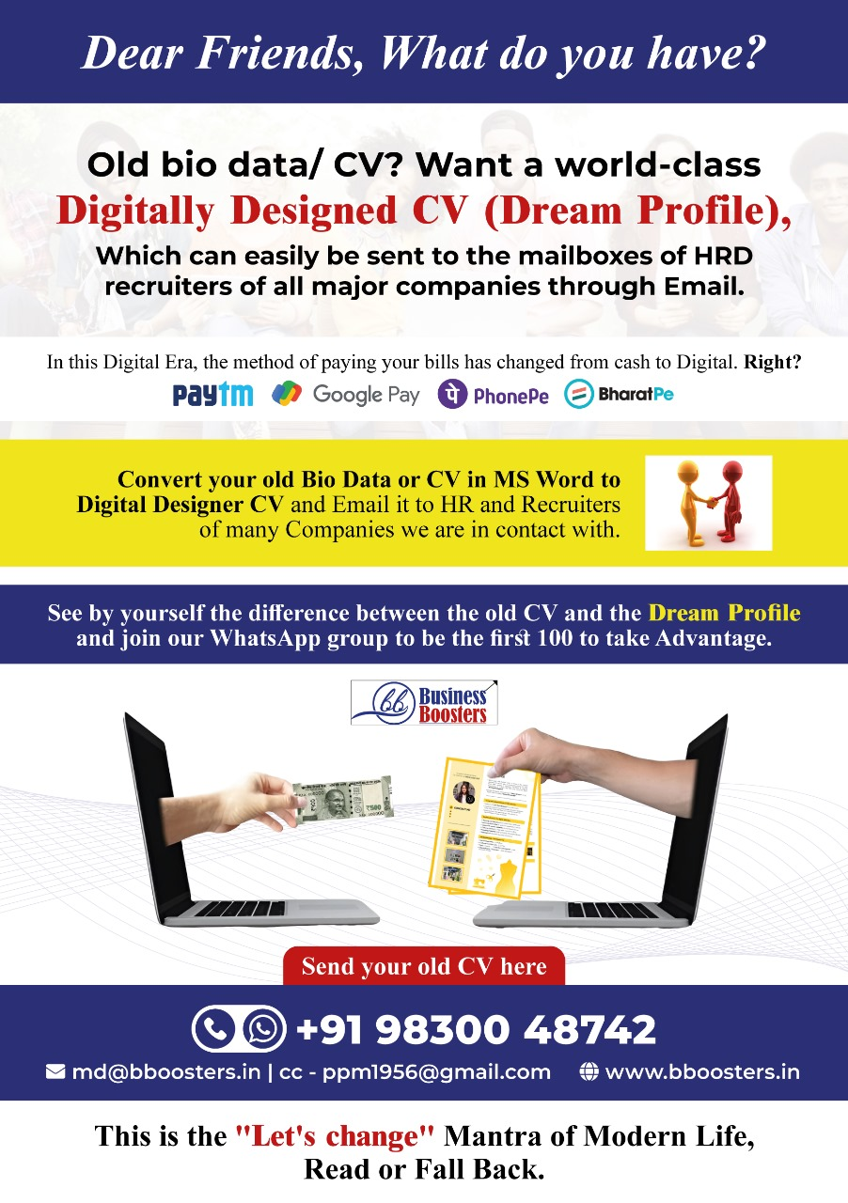

Dream Profile – Digitally Designer CV
Personal Data Sheet – 10 Points
(Pls. fill up “Your Input column” with that infmn. , if mot mentioned in the original CV submitted to BB)
NAME : Shri / Smt. ………………………………………
Sl.No | CV’s pointers | Our comments / queries | Your input
1 | Personal Particulars | Present Address - (Resi) / Contact Details Email, Mobile No., WA No./
2 | Academic Background  (Chronologically Reverse)  - Univ.  - College  - School | Year - Course Name – Specialization / Subjects – Instt. – Board – Result  (Pictures during academic period – If any/ Plz attach separately)
3 | Professionals Background  (Chronologically Reverse)  - Current Desig  - Previous  - Previous | Total Career Span (Yrs. & months) – Type of Work  Year – Orgn. Name – Designation & Scale - Posting - KRAs (5 points) – Impacts & feedbacks of superiors, if any  (Pictures during working life, if any )
4 | About Client Servicing , if any | Details
5 | Major & strategic initiatives fit for mention , if any | During the period of work so far
6 | Awards & Achievements | Year - Details – Purpose – Occasions & Photos to attach
7 | Publications | Research Papers & published articles
8 | Fluency in languages
9 | Any special item to mention
10 | Standard Infmn. Like  Date of Birth / Father’s name / Husband’s name/, if married / Wife name, if married / Details about Children / Passport No. / PAN Card No. / Adhaar Card No.

